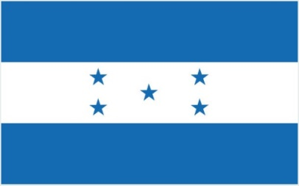
SHORT TERM SAFETY MANAGEMENT CERTIFICATE

Issued under the provisions of the International Convention for the Safety of Life at Sea, 1974,
As amended
Under the authority of the Government of

THE MERCHANT MARINE HONDURAS

By GR CLASS CLASSIFIED FOR STANDARD (GR CLASS)

SMC No.

Name of Ship | Distinctive number or letters | Port of Registry | Type of Ship1 | Gross Tonnage
 | IMO No.

Name and address of the Company
(see paragraph 1.1.2 of the ISM Code)

Company Identification Number

THIS IS TO CERTIFY THAT the safety management system of the ship has been duly audited and that it complies with the requirements of the International Management Code for the Safe Operation of Ships and for Pollution Prevention (ISM Code), following verification that the Document of Compliance for the company is applicable to the ship.

This Safety Management Certificate is valid until .
(DD-MM-YYYY)

Completion date of the verification on which this certificate is based
(DD-MM-YYYY)

Issued at Date of issue
(Place of issue of certificate) (DD-MM-YYYY)

GR CLASS Surveyor Name - ID No.

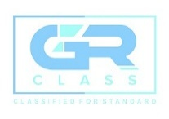

1 Insert the type of ship from among the following: Passenger ship; Passenger high-speed craft; Cargo high-speed craft; Bulk carrier; Oil tanker; Chemical tanker ; Gas carrier; Mobile offshore drilling unit; Other cargo ship.
GR CLASS – CLASSIFIED FOR STANDARD (GR CLASS)

E-mail: info@grclass.com Web: www.grclass.com
Form SMC-ST Approved by: GM Page 1 of 1

